1.INTRODUCTION

1.1 Problem Statement
In the increasing competition and time shortage, every manual system needs automation. For this purpose we make a responsive, easy to operate, fast and efficient Online Trading System. People are inclining more towards the share market so to meet the requirement of every user simultaneously we need software that will provide accurate information about share market. There was also need such system which provide directly deal with share market. Offline share trading has many disadvantages. It was less user friendly or less comfortable.

1.2 Objectives

- To make a responsive, easy to operate, fast and efficient Online Trading System.
- To provide enough flexibility to the user to use his/her time and money in a efficient and convenient way.
- To provide the facility to have the information about the stock market at home computers.
- To provide facility to Admin to add/remove a broker, from the database and also to update the database.

1.3 Scope

In the increasing competition and time shortage, every manual system needs automation. For this purpose we make a responsive, easy to operate, fast and efficient Online Trading System. People are inclining more towards the share marke so to meet the requirement of every user simultaneously we need software that will provide accurate information about share market.This system will provide this facility and thus easily acceptable by people.

1.4 Platform Specification

1.4.1 Hardware Specification

- A I3/I5 processor running at 400 MHz or faster
- Random Access Memory (RAM)
- 4GB recommended
- TCP/IP network interface card
- Local area network (LAN) card and persistent Internet connection is required.
256 GB hard disk is required.

1.4.2 Software Specification

- Microsoft Windows /Linux.
- Internet Explorer.
- Jdk1.8 or higher.
- Jakarta Tomcat as Web Server.
- MySQL as Database

    - Implementation Language

- Java
- Java Server Pages
- Java Servlet
- Html

2. SYSTEM ANALYSIS

Systems analysis is the interdisciplinary part of Science, dealing with analysis of sets of interacting or entities, the systems, often prior to their automation as computer systems, and the interactions within those systems. This field is closely related to operations research. It is also "an explicit formal inquiry carried out to help someone, referred to as the decision maker, identify a better course of action and make a better decision than he might otherwise have made.

2.1 Identification of the need

As the offline share trading systems were not very much user interactive there was a need for a system which is user interactive. There was need for a system which is responsive, easy to operate, fast and efficient, which can provide accurate information in less time.

2.2 Preliminary Investigation

We have found that offline share trading systems are not very useful. Share trading is not very easy with these systems. To meet the requirement of every user simultaneously we need software that will provide accurate information about share market.

3. FEASIBILITY STUDY
A feasibility study is a preliminary study undertaken to determine and document a project's viability or the discipline of planning, organizing, and managing resources to bring about the successful completion of specific project goals and objectives. The term is also used to describe the preliminary analysis of an existing system to see if it is worth upgrading all or a part. Also known as feasibility analysis. The term is also used to refer to the resulting document. The results of this study are used to make a decision whether or not to proceed with the project. If it indeed leads to a project being approved, it will before the real work of the proposed project start and be used to ascertain the likelihood of the project's success. It is an analysis of possible alternative solutions to a problem and a recommendation on the best alternative. It can decide, for example, whether order processing can be carried out by a new system more efficiently than the previous one.
If a project is seen to be feasible from the results of the study, the next logical step is to proceed with it. The research and information uncovered in the feasibility study will support the detailed planning and reduce the research time.
The feasibility study is done to find whether the system is beneficial to user end and organization or not. The feasibility study is carried out to select the best system that meets performance requirements. Once a relevant team member recognizes a need then the proposed system is with reference to certain parameters relates to our organization. With reference to each given below parameter, the fact is determined that “whether the system is practicable or not” and after only this evaluation system will be proceed. Parameters are given below.

3.1 Technical Feasibility
This feasibility determines the utilization of existing available hardware and software resources for within the organization because we are automating the system so we have not any previous hardware as for as software person are concern, so very short duration training will be sufficient to handle the project.
3.2 Economic Feasibility
No special investment is needed. It just requires an easily available database management system, a web server and a web browser.
3.3 Operational Feasibility
This feasibility tells how much the project and user of the project are adaptable to change. Since all the changes are for user’s benefits there will be less problem for users to accept the change.

4. LITERATURE SURVEY
Before a project is undertaken it is essential that the previously developed similar attempts are studied and referred for getting a brief over view of the requirements, schemas and other constraints.
4.1 Benefits
This system has the following benefits :-
- This system is a responsive, easy to operate, fast and efficient Online Trading System.
- This system provides enough flexibility to the user to use his/her time and money in a efficient and convenient way.
- This system provides the facility to have the information about the stock market at home computers.
- This system provides facility to Admin to add/remove a broker, from the database and also to update the database.
4.2 Proposed Solution
This System provides the facility to user to deal with share market. This system provide following facility
- To make a responsive, easy to operate, fast and efficient Online Trading System.
- To provide enough flexibility to the user to use his/her time and money in a efficient and convenient way.
- To provide the facility to have the information about the stock market at home computers.
- To provide facility to Admin to add/remove a broker, from the database and also to update the database.
4.3 Technology Used
JAVA SERVER PAGE:

Java Server Pages (JSP) is a Java technology that allows software developers to dynamically generate HTML, XML or other types of documents in response to a Web client request. The technology allows Java code and certain pre-defined actions to be embedded into static content.
The JSP syntax adds additional XML-like tags, called JSP actions, to be used to invoke built-in functionality. Additionally, the technology allows for the creation of JSP tag libraries that act as extensions to the standard HTML or XML tags. Tag libraries provide a platform independent way of extending the capabilities of a Web server.
JSP are compiled into Java Servlets by a JSP compiler. A JSP compiler may generate a servlet in Java code that is then compiled by the Java compiler, or it may generate byte code for the servlet directly. JSP can also be interpreted on-the-fly reducing the time taken to reload changes.

JAVA SERVLET:
The Java Servlet API allows a software developer to add dynamic content to a Web server using the Java platform. The generated content is commonly HTML, but may be other data such as XML. Servlets are the Java counterpart to non-Java dynamic Web content technologies such as PHP, CGI and ASP.NET. Servlets can maintain state across many server transactions by using HTTP cookies, session variables or URL rewriting.

Tools
JAKARTA Apache:
Jakarta Apache is a servlet container which implements the Java Servlet and the Java server pages (JSP), and provides a “pure Java” HTTP web server environment for Java code to run. Apache is the most popular platform for deploying Java-based Web application. Apache Tomcat powers numerous large-scale, mission-critical web applications across a diverse range of industries and organization. Tomcat 5.x is an implementation of the Java Servlet 2.4 and Java Server Pages 2.0

specifications, with increased attention to scalability, reliability, and management functionality.

MY-SQL:
MySQL is a relational database management system that runs as a server providing multi- user access to a number of databases. My sql has lots of advantage Available and affordable for all, Easy to use, Continuously improved while remaining fast, secure, reliable ,Fun to use and improve, Free from bugs.

5. TECHNICAL PART
5.1 Project Standard

This simulation is a web based application.
5.2 Proposed Tools
* Mysql, Eclips 22-12

5.3 Description of hardware and software
Software

- Microsoft Windows /Linux.
- Google Crome.
- Jdk 1.8 or higher.
- Jakarta Apache Server as Web Server.
- MySQL as Database

Hardware
- A I3/I5 processor running at 400 MHz or faster
- Random Access Memory (RAM)
- 4 GB recommended
- TCP/IP network interface card
- Local area network (LAN) card and persistent Internet connection is required.
- 256 GB hard disk is required.

5.4 Interfaces
Person can login to the system in three different ways. According to the role specified, system provides functionality to him. If the admin logins to the system he can communicate with the database directly, gets all the rights over the database. If a broker logins to the system he can communicate with the customer, and a user gets access to his account only. Thus only administrator can communicate with the database directly.

5.5 Security
This system is secured as each user is provided a password. Only a registered person can log in to the system. And no one except admin is allowed to make any changes to the database. Thus this system is totally secured.
5.6 Coding language
In OSTM we used Java. Java was conceived by James Gosling, Patrick Naughton, Chris Warth, and Mike Sheridan at Sun Microsystems, Inc. in 1991. It was initially called “oak” but was renamed “java” in 1995. Java is a simple, object-oriented language . Java buzzwords:
- Simple:- Java was designed to be easy for the professional programmer to learn and use effectively. If you are an experienced C++ programmer moving to java will require little effort because Java inherits the C/C++ syntaxand many of the object=oriented features of C++.
- Object- oriented:- Java has a clean, usable, pragmatic approach to objects. Java manages to strike a balance between the purist’s “everything is an object” paradigm and the pragmatist’s “stay out of my model”. The object model in java is simple and easy to extend, while primitive types such as integers, are kept as high-performance non objects.
- Robust:- The ability to create robust programs was given a high priority in java. Because java is a strictly typed language, it checks code at compile time. However it also checks code at run time. Java manages memory allocation, deallocation, exceptional conditions, all run time errors.
- Multithreaded:- Java supports multithreaded programming, which allows you to write programs that do many things simultaneously.
- Dynamic:- Java programs carry with them substantial amounts of run time tye information that is used to verify and resolve accesses to objects at run time. This makes it possible to dynamically link code in a safe and expedient manner.

JAVA SERVLET:

The Java Servlet API allows a software developer to add dynamic content to a Web server using the Java platform. The generated content is commonly HTML, but may be other data such as XML. Servlets are the Java counterpart to non-Java dynamic Web content technologies such as PHP, CGI and ASP.NET. Servlets can maintain state across many server transactions by using HTTP cookies, session variables or URL rewriting.
The Servlet API, contained in the Java package hierarchy javax.servlet, defines the expected interactions of a Web container and a servlet. A Web container is essentially the component of a Web server that interacts with the servlets. The Web container is responsible for managing the lifecycle of servlets, mapping a URL to a particular servlet and ensuring that the URL requester has the correct access rights.
A Servlet is an object that receives a request and generates a response based on that request. The basic servlet package defines Java objects to represent servlet requests and responses, as well as objects to reflect the servlets configuration parameters and execution environment. The package javax.servlet.http defines HTTP-specific subclasses of the generic servlet elements, including session management objects that track multiple requests and responses between the Web server and a client. Servlets may be packaged in a WAR file as a Web application.
Servlets can be generated automatically by Java Server Pages (JSP), or alternately by template engines such as Web Macro. Often servlets are used in conjunction with JSP in a pattern called "Model 2", which is a flavor of the model-view-controller pattern.

- LIFE CYCLE OF SERVLETS
The Servlet life cycle consists of the following steps:
- The Servlet class is loaded by the container during start-up.
- The container calls the init () method. This method initializes the servlet and must be called before the servlet can service any requests. In the entire life of a servlet, the init () method is called only once.
- After initialization, the servlet can service client-requests. Each request is serviced in its own separate thread. The container calls the service () method of the servlet for every request. The service () method determines the kind of request being made and dispatches it to an appropriate method to handle the request. The developer of the servlet must provide an implementation for these methods. If a request for a method that is not implemented by the servlet is made, the method of the parent class is called, typically resulting in an error being returned to the requester.
- Finally, the container calls the destroy () method which takes the servlet out of service. The destroy () method like init () is called only once in the life-cycle of a Servlet.

JAVA SERVER PAGES:
Java Server Pages (JSP) is a Java technology that allows software developers to dynamically generate HTML, XML or other types of documents in response to a Web client request. The technology allows Java code and certain pre-defined actions to be embedded into static content.
The JSP syntax adds additional XML-like tags, called JSP actions, to be used to invoke built-in functionality. Additionally, the technology allows for the creation of JSP tag libraries that act as extensions to the standard HTML or XML tags. Tag libraries provide a platform independent way of extending the capabilities of a Web server.
JSP are compiled into Java Servlets by a JSP compiler. A JSP compiler may generate a servlet in Java code that is then compiled by the Java compiler, or it may generate byte code for the servlet directly. JSP can also be interpreted on-the-fly reducing the time taken to reload changes.

6. SOFTWARE ENGINEERING APPROACH

6.1 Software Engineering Paradigm Applied

In this simulation we are using Waterfall Model .

6.1.1 Description

Waterfall model is the oldest software paradigm. This model suggests a systematic, sequential approach to software development. This model is also called linear-sequential model. The software development starts with requirements gathering phase. Then progresses through analysis, design, coding, testing and maintenance.
In requirement gathering and analysis phase the basic requirements of the system must be understood. All these requirements are then well documented.
Design focuses on program attributes such as data structure, software architecture, interface representation, algorithmic details.
Coding is a step in which design is translated into machine-readable form. Programs are created in this phase.
Testing begins when coding is done. While performing testing the major focus is on logical internals of the software. The testing ensures execution of all the paths, functional behaviours. The purpose of testing is to uncover errors, fix the bugs and meet the requirements.
Maintenance is the longest phase. When the system is installed and put in practical use then error may get introduced, correcting such errors and putting it in use is the major purpose of maintenance activity

.
Requirement gatheribg and Analysis
Design

Coding

Testing

Maintenance

Fig. Waterfall Model

6.1.2 Advantages and Disadvantages

Advantages-
- Waterfall model is simple to implement.
- For implementation of small systems waterfall model is useful.

Disadvantages-
- It is difficult to follow the sequential flow in software development process.
- The requirement analysis is done initially and sometimes it is not possible to state all the requirements explicitly in the beginning.

6.1.3 Reasons for use

We are using waterfall model in this simulation since it is easy to implement. All the requirements for developing this software are explicitly declared.

6.2 Requirement Analysis
A Requirement is a feature of the system or a description of something; the system is capable of doing in order to fulfill the system purpose. Requirement Engineering provides the appropriate mechanism for understanding what the customer wants, analyzing needs, assessing feasibility, negotiating a reasonable solution, validating the specification and managing the requirements as they are transformed into an operational system. Our application package helps the planner and manager in a guided way to perform his/her tasks in effective manner even if he is unaware of the details of the software program. The objective of any value added package or application program is to support and decision-making and analysis.

6.2.1Software Requirement Specification
It is an s/w engineering task that bridges the gap b/w system level requirement engineering and s/w design. Requirement analysis allows the s/w engineer to refine s/w requirement and build models of data, functional and behavioral domain that will be treated by s/w.

6.2.1.1 Glossary
- Activity Diagram – A diagram that shows flow from activity to activity.
- GUI – A Graphical User Interface that has windows, buttons and menus used to carry out -
- Project – Any piece of work that is undertaken or attempted.
- Report – A written document describing the findings of some individual or group.
- Sequence Diagram – An interaction diagram that emphasizes the time ordering of messages.

6.2.1.2 Supplementary Specification
The Java Servlet API allows a software developer to add dynamic content to a Web server using the Java platform. The generated content is commonly HTML, but may be other data such as XML. Servlets are the Java counterpart to non-Java dynamic Web content technologies such as PHP, CGI and ASP.NET. Servlets can maintain state across many server transactions by using HTTP cookies, session variables or URL rewriting.
The Servlet API, contained in the Java package hierarchy javax.servlet, defines the expected interactions of a Web container and a servlet. A Web container is essentially the component of a Web server that interacts with the servlets. The Web container is responsible for managing the lifecycle of servlets, mapping a URL to a particular servlet and ensuring that the URL requester has the correct access rights.

6.2.1.3.Use Case Model

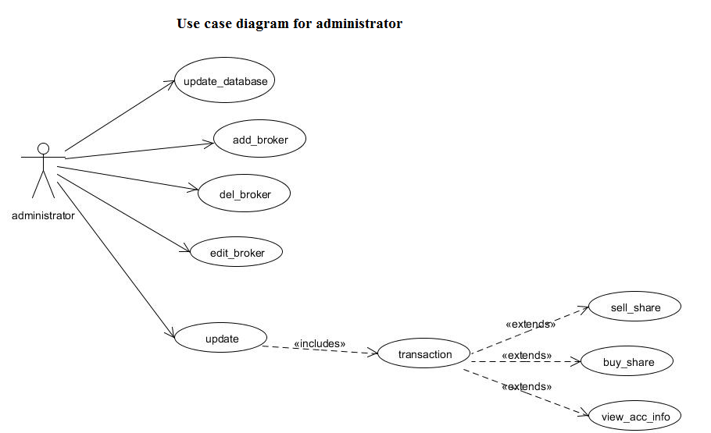

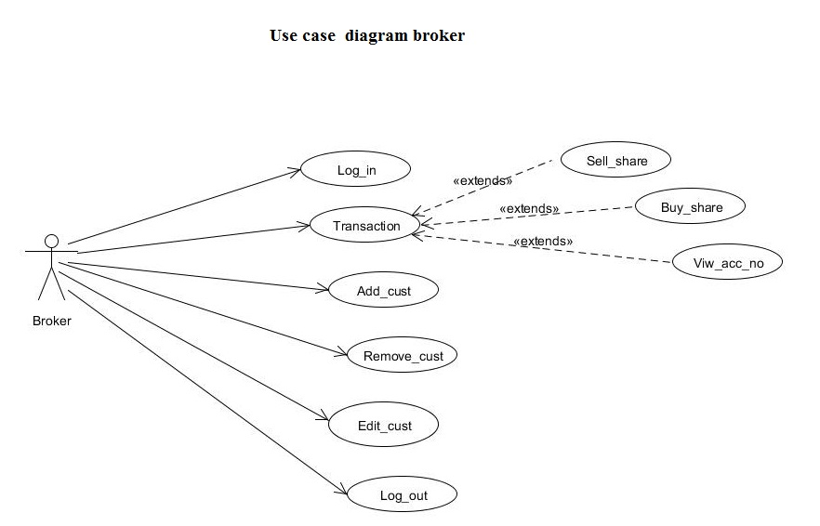

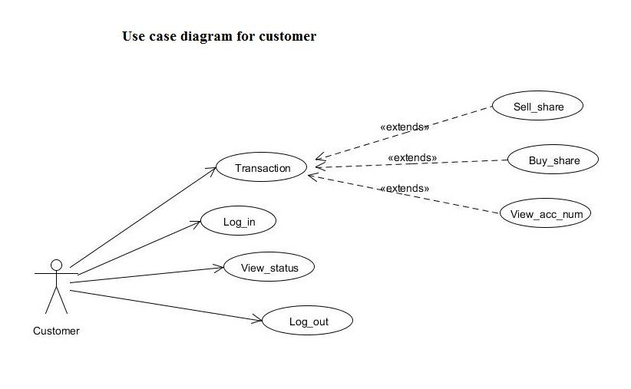

6.2.2. Conceptual Level Class Diagram:

For Administrator:

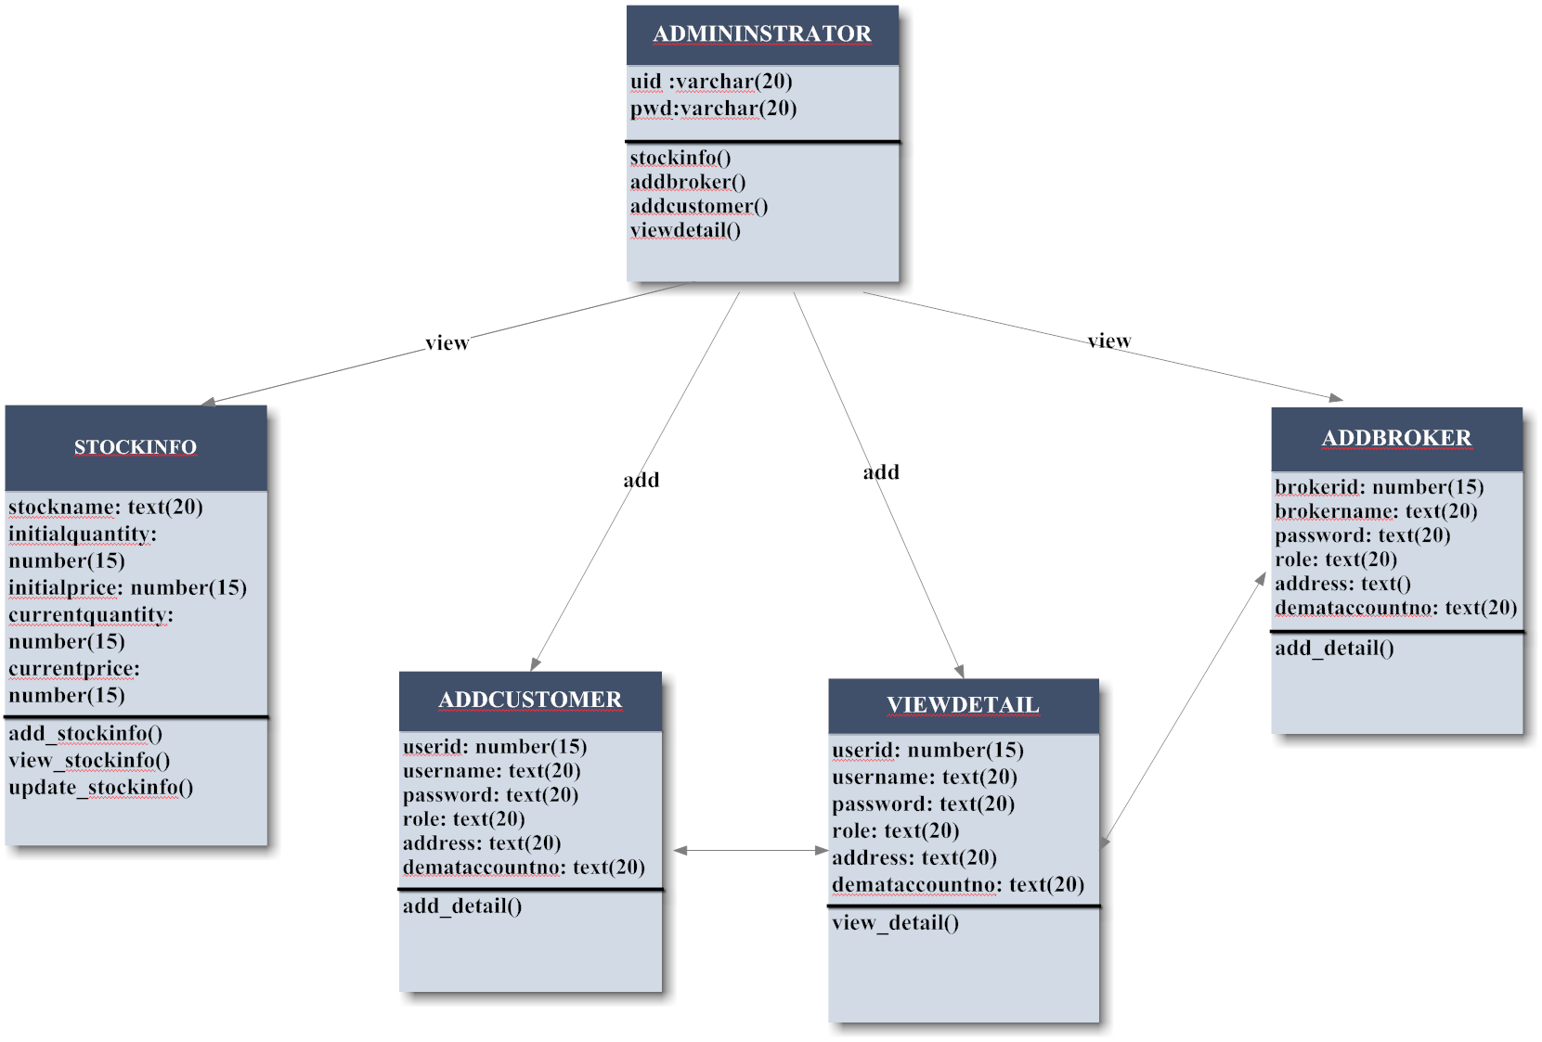

For Broker:

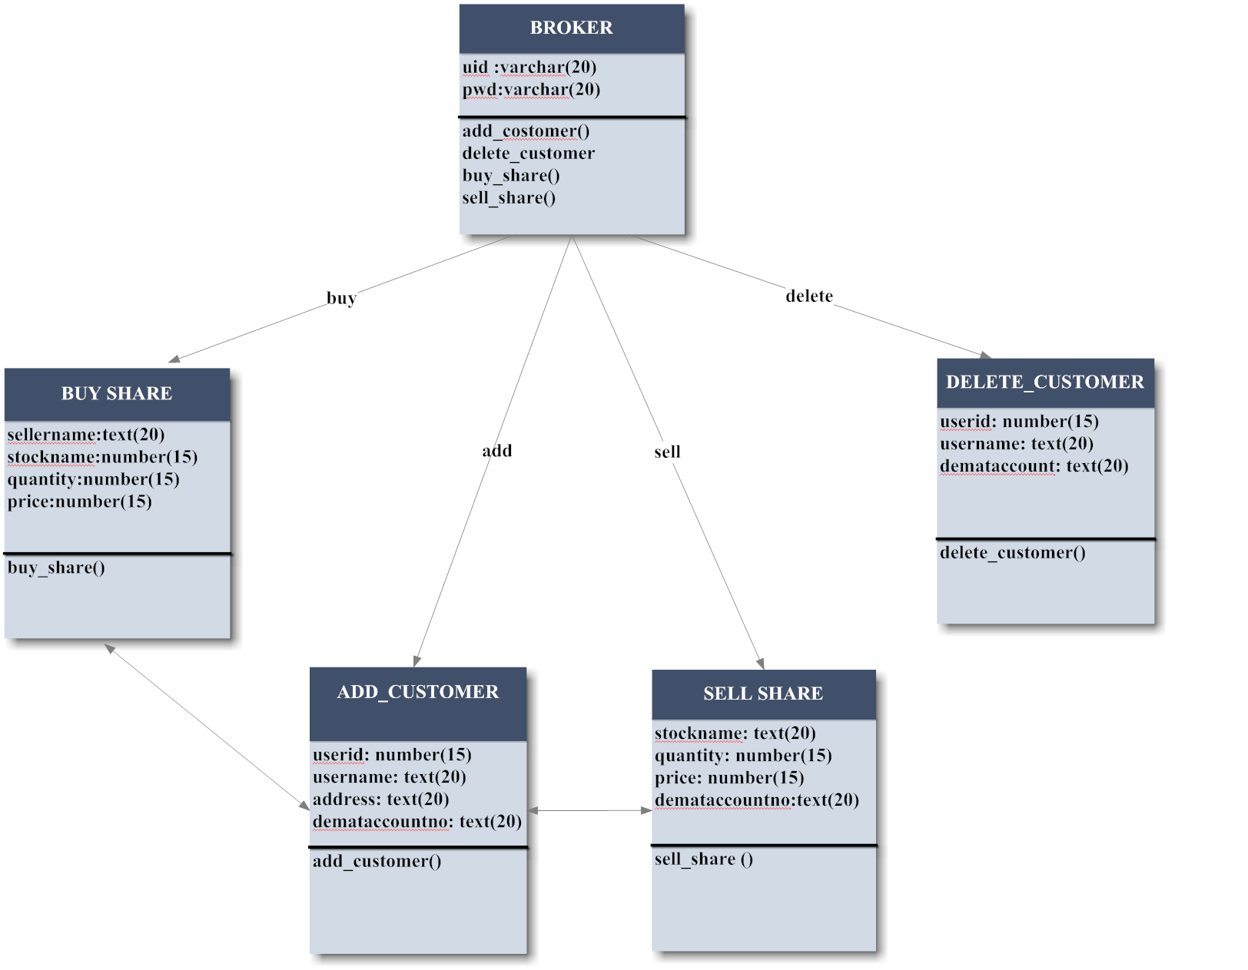

For User:

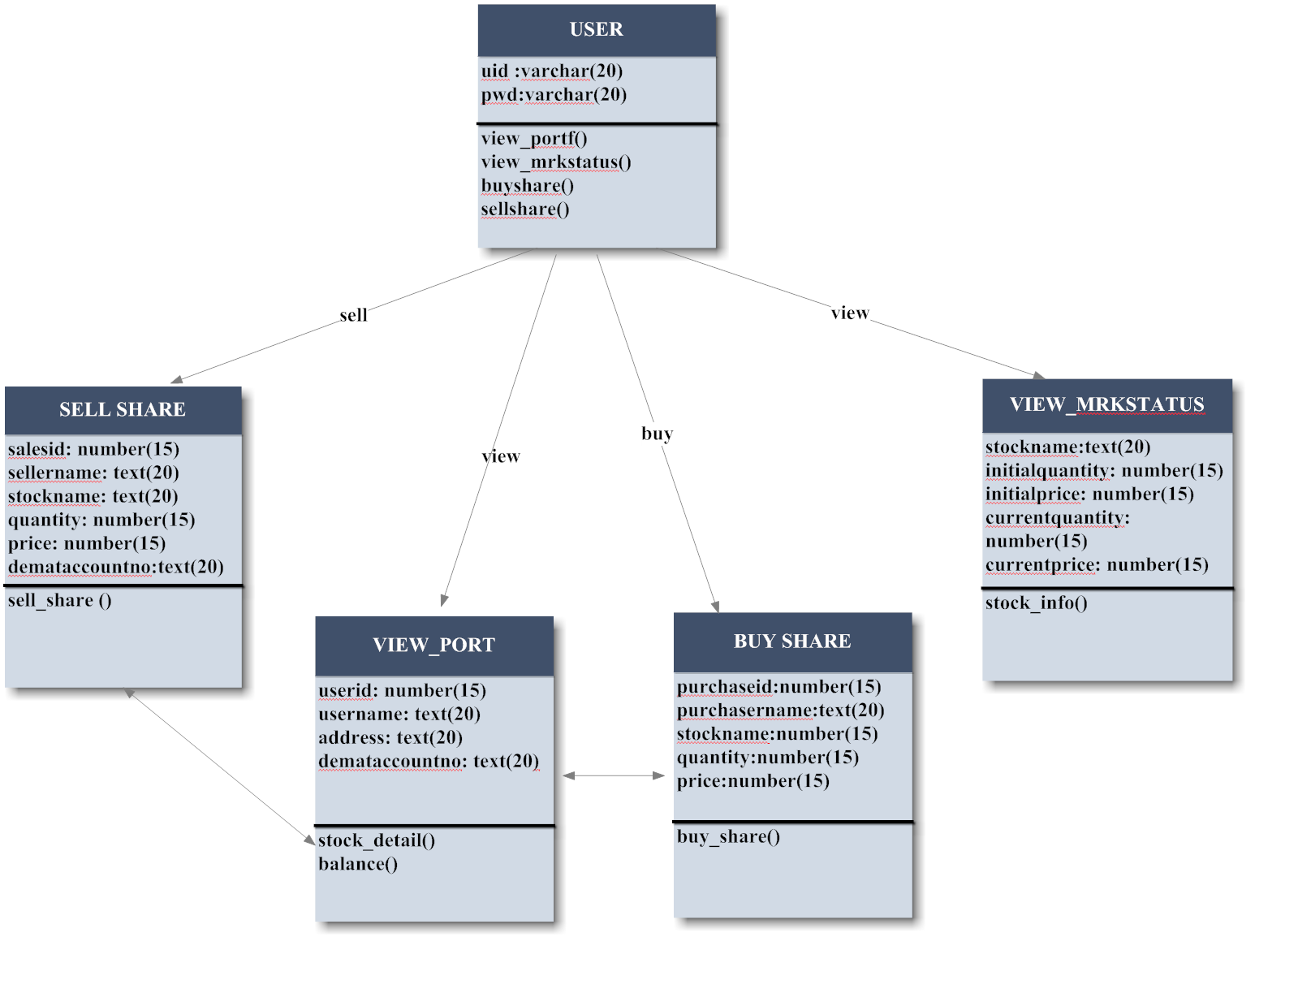

6.3 Plannning Managerial issue
6.3.1 Planning scope
This system is productivity software using information technology. This software provides the reader with general, background information about the web site “Online Trading System”.This is a simulation to real online share trading. Since people are inclining more towards the share market so to meet the requirement of every user simultaneously we need software that will provide information at free hours. This software can be achieved by using the above mentioned state.
In present scenario, with the increasing competition and time shortage, every manual system needs automation. Internets become essential part of the day to day life. This utility is used by almost everyone in his day to day life. There is a need for a system which can provide accurate information in less time.
This system upon receiving the requests looks-up the underlying database and sends the appropriate response to the user.

6.3.2 Team Organization
Our Team Structure is Democratic Decentralized.
In Democratic Decentralized team structures following features are observed:
C
C
C
AB
BAB

A - Project Guides
B - Information source (Books and Internet)
C –Team member

- It has no team leader. All players are at the same level.
- Problem solving is done in-groups.
- It has high degree of sociability.
- It is generally employed for small projects.

All the above stated properties are observed in our project. Thus, the team structure of our project is Democratic Decentralized.
6.3.3 PROJECT SCHEDULING
Project is completed within 3 months.

Timeline Chart

Activity. No. | Work Task | M1 | M2 | M3 | M4 | M5 | M6 | M7
1.1.1 | Meeting Knowledgeable People
1.1.2 | Identifying Requirements
1.1.3 | Identifying Constraints
1.1.4 | Study Problem Statement
1.1.5 | Identify Project Definition
1.1.6 | Establish Goals of the Project
1.1.7 | Analyze Benefits
1.1.8 | Establish Scope of Project
1.1.9 | Advantages and Disadvantages
1.1.10 | Requirement Documentation
1.1.11 | Requirement Specification
1.1.12 | Normal, Expected, Exciting Req.
1.1.13 | General Types of Requirements
Milestone 1
1.2.1 | Study of various process models
1.2.2 | Selection of a Process Model
1.2.3 | Study advantages/disadvantages
1.2.4 | Define Human Resources
1.2.5 | Define Reusable Resources
1.2.6 | Define Environment Resources
1.2.7 | Project Team Organization
1.2.8 | Work Style

6.3.4 Estimation
Effective software project estimation is one of the most challenging and important activities in software development. Proper project planning and control is not possible without a sound and reliable estimate. As a whole, the software industry doesn’t estimate projects well and doesn’t use estimates appropriately.
The four basic steps in this software project estimation are:

- Estimate the size of the development product. This generally ends up in either Lines of Code (LOC) or Function Points (FP), but there are other possible units of material referenced at the end of this report.
- Estimate the efforts in person-months or person-hours.
- Estimate the schedule in calendar months.
- Estimate the project cost in rupee.

6.3.5 Risk Analysis
Risk analysis and management arc a series of steps that help a software team to understand and manage uncertainty. A risk always involves two characteristics.
1) Uncertainty – The risk may or may not happen; that is, there are no 100% probable risks.
2) Loss - If the risk becomes a reality, unwanted consequences or losses will occur.

TYPES OF RISK

A risk is any unfavorable event or circumstance that can occur while a project is underway. If a risk becomes true, it can hamper the successful and timely completion of a project. Therefore, it is necessary to anticipate and identify different risks that a project is susceptible to, so that a contingency plan may be prepared in advance to contain the effects of each risk. Risk management aims at dealing with all kinds of risks that might affect a project.
We quantify the level of uncertainty and the degree of loss associated with each risk, when we analyze the different categories of risks that are considered.

- PROJECT RISK

Project risks threaten the Project Plan. For example, if a project risk occurs in reality, then it is likely that the project schedule will slip and that the costs will increase. Project risks identify potential budgetary, schedule, personnel, resource, customer, and requirements problems and their impact on a software project.

- TECHNICAL RISK

Technical risks threaten the quality and timeliness of the software to be produced. A technical risk makes implementation difficult or at times, impossible. Technical risks identify the potential design, implementation, interfacing, maintenance, and verification problems.

- BUSINESS RISK

Business risks threaten the viability of the software to be built. Business risks often jeopardize the product or project. This risk occurs when a product or a system is built correctly but is not wanted in the market (known as Market Risk), or when a product is built without keeping the overall business strategy of the company in mind (known as Strategic Risk), or when a product does not fetch the price in the market it is expected to (known as Sell Risk), or when the team members do not work cohesively towards completing the product (known as Management Risk), or when the cost of the product exceeds the budgetary allocation (known as Budget Risk).

- KNOWN RISK

Known risks are those risks that are previously known to the developers. These risks include the delays related to the delivery date of the project.

- PREDICTABLE RISK

Predictable risks are risks that can be foretold based on experience gained in developing past projects, or in developing previous segments of the current project. For example, a risk ignored in the analysis phase is likely to cause a risk in the design phase.

- UNPREDICTABLE RISK

Unpredictable risks are undesirable events that occur unexpectedly. This type of risk covers such situations like the one where the user changes his requirements during the development of the project.

6.3.6 Security plan
This system is secured as each user is provided a password. Only a registered person can log in to the system. And no one except admin is allowed to make any changes to the database. Thus this system is totally secured.

6.4 DESIGN
6.4.1 Design Constraints
Design constraints of the system involves the limitations provided to the user as user cannot make any changes to the database, user can access his account only. Broker is also bounded by some limitations as he cannot alter the database, he can only add or delete the customer, can do the trading for customer. And administrator has all the rights over the database, all trading activities are done under the supervision of the administrator

6.4.2.Design Techniques

In our project we are following Object Oriented Design strategie. The software product can be designed using structured oriented method or using object oriented techniques. There are some merits and demerits associated with these systems which directly affect
The software development process.
The object oriented analysis is a technique in which main emphasis is on objects. Each object is a combination of data members and member functions.
The use cases, class diagrams, sequence diagrams, state chart diagram, activity diagram, component diagrams can be drawn in this method.

6.4.3.Modelling
6.4.3.1. Class Diagram
6.4.3.1.1. Class Diagram for Administrator:

6.4.3.1.2. Class Diagram for Broker:

6.4.3.1.3. Class Diagram for User:

6.4.3.2. Sequence Diagram

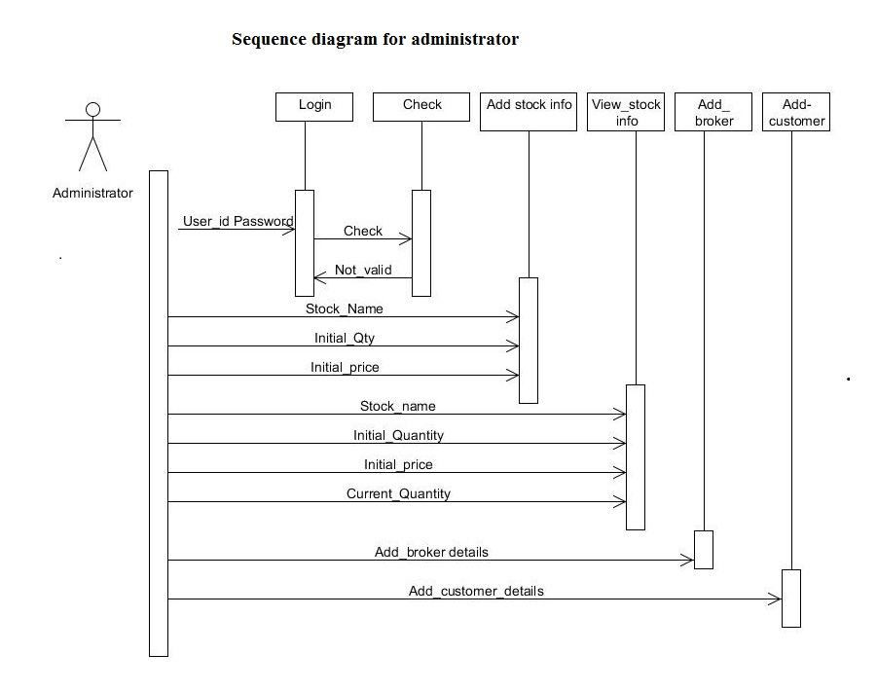

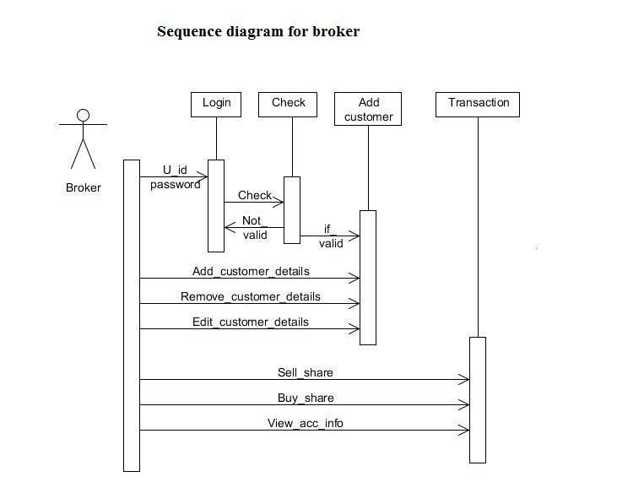

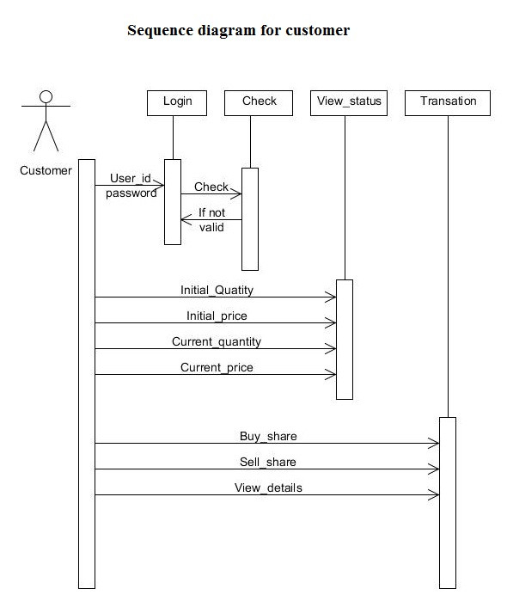

6.4.3.3. Activity Diagram
For Administrator:

Login
View stock Info
List Customers and Brokers

Logout
Add New Stocks
Add Broker
Add Cust.

6.4.3.4. Data Flow Diagram
6.4.3.4.1. Level 0 Data Flow Diagram

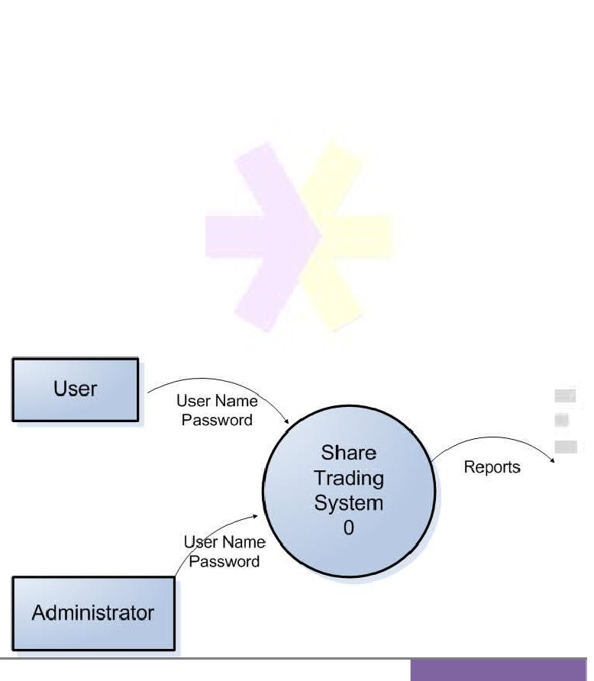

6.4.3.4.2. Level 1 Data Flow Diagram

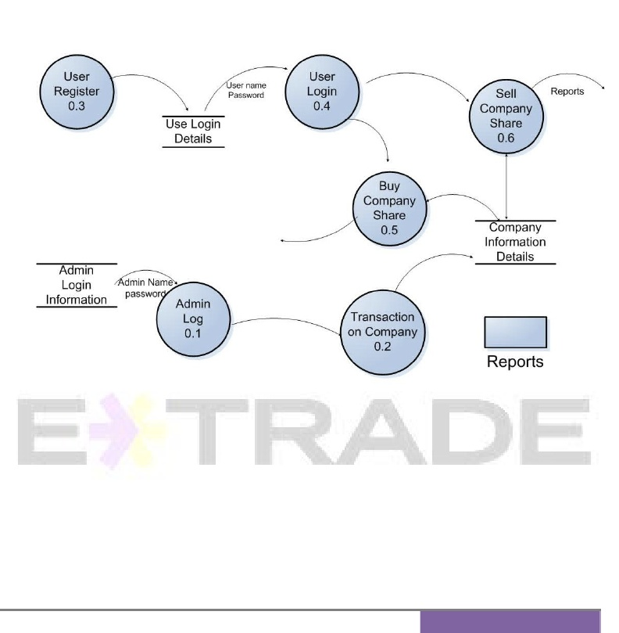

6.4.3.4.3. Level 2 Data Flow Diagram

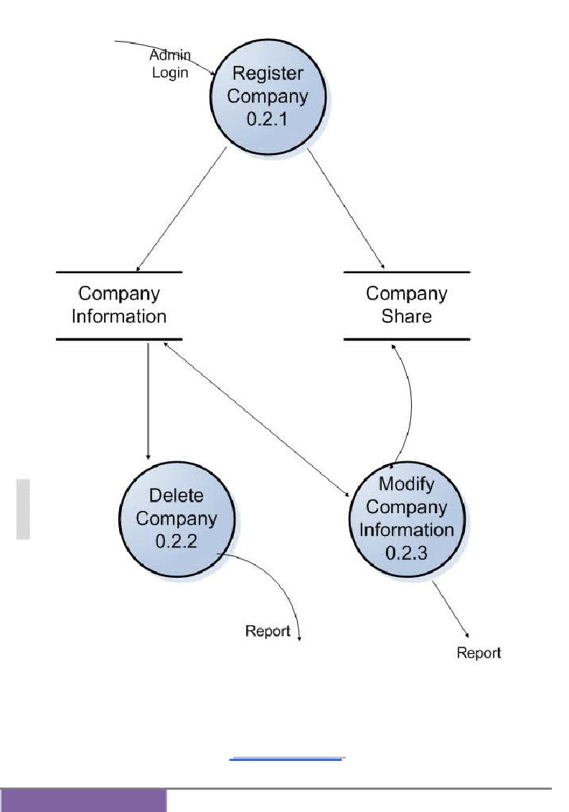

6.4.3.5. E-R Diagram:

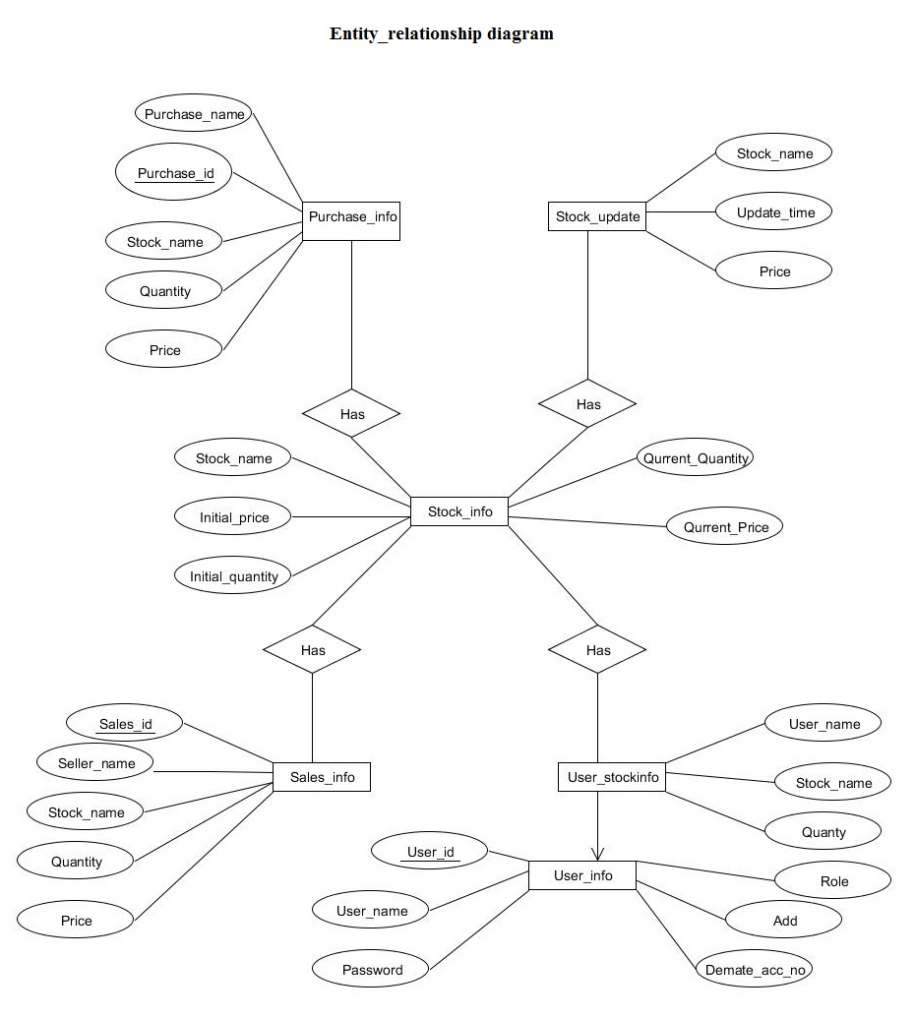

6.5 Implementation phase
6.5.1 Language used characteristics
In OSTM we used Java. Java was conceived by James Gosling, Patrick Naughton, Chris Warth, and Mike Sheridan at Sun Microsystems, Inc. in 1991. It was initially called “oak” but was renamed “java” in 1995. Java is a simple, object-oriented language . Java buzzwords:
- Simple:- Java was designed to be easy for the professional programmer to learn and use effectively. If you are an experienced C++ programmer moving to java will require little effort because Java inherits the C/C++ syntaxand many of the object=oriented features of C++.
- Object- oriented:- Java has a clean, usable, pragmatic approach to objects. Java manages to strike a balance between the purist’s “everything is an object” paradigm and the pragmatist’s “stay out of my model”. The object model in java is simple and easy to extend, while primitive types such as integers, are kept as high-performance non objects.
- Robust:- The ability to create robust programs was given a high priority in java. Because java is a strictly typed language, it checks code at compile time. However it also checks code at run time. Java manages memory allocation, deallocation, exceptional conditions, all run time errors.
- Multithreaded:- Java supports multithreaded programming, which allows you to write programs that do many things simultaneously.
- Dynamic:- Java programs carry with them substantial amounts of run time tye information that is used to verify and resolve accesses to objects at run time. This makes it possible to dynamically link code in a safe and expedient manner.

